A Publicity and marketing company decided to prompt two types of products they X ,Y each product has three levels of validation for the quality and value the total no of workers allocated for each levels are for X 10,20,30 and for Y 20,30,40 the total no of workers allocated for type X is 200 and for type Y is 250 the total time given level-1 is 200 level-2 is 300 level-3 400.

Sol:

Type level-1 level-2 level-3 total workers

X 10 20 30 200

Y 20 30 40 250

200 300 400

the objective function is

Z = 200x1+250x2

Subject to:

10x1 + 20 x2 <=200

20x1 + 30x2 <=300

30x1 +40x2 <=400

x1>0 ; x2>0

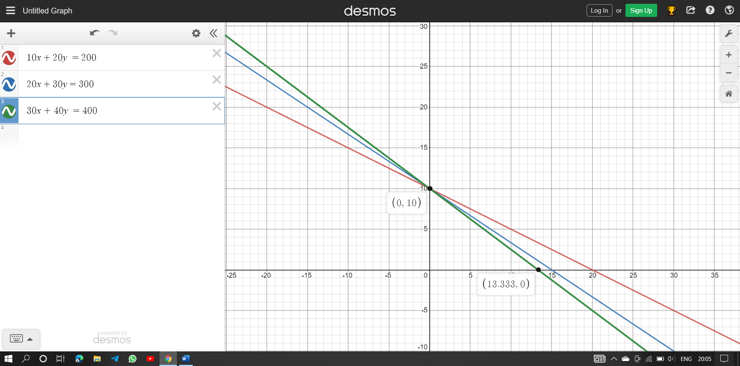

The points are (0,10) , (13.33,0) ,(0,0)

Point Z

0,10 2500

0,0 0

13.33,0 2666 x1=13.33 x2 = 0

Example 1:

import numpy as np  
import matplotlib.pyplot as plt  
x=np.linspace(**0,20,30**)  
y=**18**-**2**\*x  
y1=(**42**-**2**\*x)/**3**plt.plot(x**,**y**,**label='2x+y=18')  
plt.plot(x**,**y1**,**label='2x+3y=42')  
plt.legend()  
plt.show()  
def endpoints(Cx**,**Cy**,**B):  
 p1=[]  
 p2=[]  
 p1.append(**0**)  
 p1.append(B/Cy)  
 p2.append(B/Cx)  
 p2.append(**0**)  
 return p1**,**p2  
def intersecting_points(a1**,**b1**,**c1**,**a2**,**b2**,**c2):  
 D=a1*b2-a2*b1  
 Dx=c1*b2-c2*b1  
 Dy=a1*c2-a2*c1  
 if D==**0**:  
 return 'lines are not interesecting'  
 else:  
 return x**,**y  
 p**,**q=intersecting_points(**2,1,18,2,3,42**)  
 plt.grid(alpha=**.4,**linestyle='--')  
 plt.xlim(**0,50**)  
 plt.ylim(**0,50**)

output :

